Doc Writer: Poornachandra Chejerla Doc Date: January 12, 2015
Application or System Name
Profile Automation (BL_ENH_POST_004)
General Overview
Business Requirements:
Device register setup, creation and allocation of interval profile will be automated for GSD demand AMI capable meter. The developed functions will be called from following process:

- After Deployment and GD validation , AMI meter will cut over to IB
- New service request for brand new premises with GSD rate category
- New Move In with GSD rate category
- Service Upgrade with GSD rate category
- From Z transaction code which will enable automation of profile for miscellaneous cases including GS rate analysis.

The Automation of profile function module will be designed to carry out following steps:
- Device Register Modification
- Creation of Profile
- Allocation of Profile
- Interval Profile Synchronizations with MDMS

Technical Design:
Function module name: Z_REG_AMCG_PROFILE_UPDATE

- Performs basic validations like Equipment Number available or not and Activity date available or not and date is not future date for automation of profile and Equipment is installed at device location or not and Installation exists for device during activity period etc.
- This functionality is done in the method zcl_edmprofile_automation->do_basic_validations( )
- Gets necessary data like custom Register data and rate category and billing installation data.
- This functionality is done in the methods
zcl_edmprofile_automation->get_rate_category( ).
zcl_edmprofile_automation ->get_billinst_data( )
- Based on combination of rate category , register group id and billing flag , program will determine adjustment of register attributes and will be done based on values available in table ZTCC_BILINS_ELEC. The table will be used as a reference table to modify register and rate attributes
- As part of device modification register values and rate data and bill factor details and device register relationships to the meter is updated and EDM profile is created and assigned to installation.

- Device Register Modification :
  - Device modification is performed and appropriate register values updated to the meter with the help of function modules 'ISU_S_DEVICEMOD_PROVIDE' and 'ISU_S_DEVICEMOD_CHANGE' and 'ISU_S_DEVICERATE_CHANGE'
  - If the device modification process is unsuccessful then stop further processing and give an error message in the application log with the key parameters.
  - This functionality is done in the method zcl_device_modif_util->perform_dev_mod( )
  - As part of device modification rate data is updated to the meter with the help of function modules 'ISU_S_DEVICERATE_PROVIDE' and 'ISU_S_DEVICERATE_CHANGE'.
  - This functionality is done in the method zcl_device_modif_util->perform_rate_changes( )
  - If maintaining rate data process is unsuccessful then stop further processing and give an error message in application log with the key parameters. If this step is successful then proceed further.
  - Bill factor details and device relationships for device is updated to the meter using function modules 'ISU_S_DEVICEREL_PROVIDE’ and ‘ISU_S_DEVICEREL_CHANGE’.

- Creation of Profile:
  - Creates EDM profile for post cut over max demand with function module 'ISU_S_PROFHEAD_CREATE’.
  - This functionality is done in the method zcl_edmprofile_automation ->create_edm_profile( ).
- Allocation of Profile:
  - The created profile need to be allocated to installation and to interval register of device. Perform profile allocation for new installation for the new device with the available start date and with the end date 12/31/9999. This will be done by function module 'ISU_S_PROFASS_CHANGE’.
  - This functionality is done in the method zcl_edmprofile_automation ->assign_edm_profile( )
- Interval Profile Synchronizations with MDMS:
  - After allocation of profile, to synchronize EDM profile to the MDM a message should be triggered to notify MDM of the profile allocation to a register this functionality is done in the method
zcl_edmprofile_automation ->synchronize_profiles( ).
  - This method treats each interval for the mass activity eamiprofsync .It first retrieves all the profiles from the interval and then builds application data used by the enterprise service UtilitiesTimeSeriesERPReplicationBulkRequest Out

  - After completion of functionality, application message log will be generated with appropriate messages and with key parameters.
- De allocation of the EDM profiles:
  - De allocates the EDM profile using Function module ‘ISU_O_PROFASS_ACTION’.
  - zcl_edmprofile_automation ->process_profile_deallocate( )

System Diagram
☐ Screen that’s presented 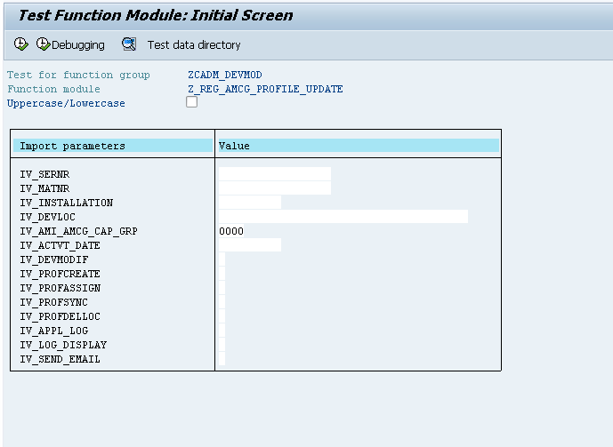

Technical Parts Inventory
-------Name------- | --Description-- | --Location-- | -Environment--
Z_REG_AMCG_PROFILE_UPDATE | Function Module |  | E2D
ZCL_EDMPROFILE_AUTOMATION | Class |  | E2D
ZCL_DEVICE_MODIF_UTILl | Class |  | E2D

Dependent Parts Inventory
----Name----- | ----Description--- | ---Location---- | ---Environment---

Security Roles and AD Group Needed to Run App

